# How to access web mail/outlook web app

## Details

Webmail or Outlook Web Access (OWA) from Microsoft Office 365 provides the ability for you to check your @kp.org email, using nothing more than a web browser. Instead of using Outlook on your local computer, you simply browse to a [web address](https://webmail.kp.org/) and then log in and check your e-mail.

To access webmail, you must have an established connection to the KP network (Direct ethernet connection, Aruba, KP Wi-Fi, Global Protect, VPN) or you must be a member of O365 External Access group with a valid PingID account.

## Applies To

|  |
| --- |
| * **Article Confidence:** * **Environment:**Production or Non-Production   + Application and Version(s) Office 365 * **Regions:** ALL * **User Segment:**ALL, Affiliates, Contact Center, Contingent Worker, Corporate Worker, Day Extender, Executive, Physician, Point of Care |

## Steps

1. From a web browser (Internet Explorer, Chrome, Edge), go to <https://webmail.kp.org/>

1. Enter your kp.org email address if prompted.  
   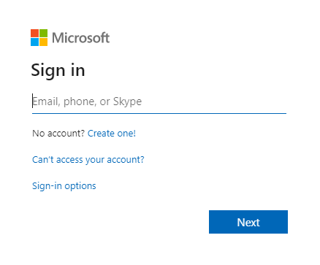

1. Click “Next”  
   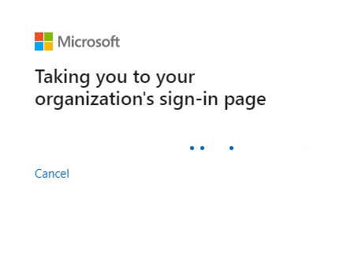

1. If prompted to stay signed in, select “Yes”  
   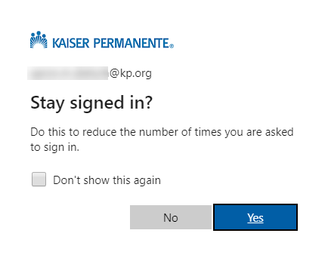

1. You are then logged in and directed to your Outlook mailbox  
   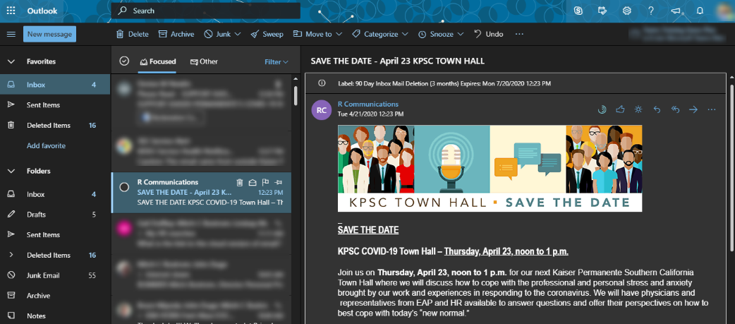

## View More

<https://kp.service-now.com/kb_view.do?sys_kb_id=35705f351b5894dcb624c8451a4bcbe0>

# How to change outlook email signature

## Applies To

|  |
| --- |
| * **Environment:**Production   + Application and Version(s): Outlook Web Application (OWA) * **Regions:** CO, GA, HI, MAS, NW, NCAL, SCAL, WA * **User Segment:**[Affiliates, Contact Center, Contingent Worker, Corporate Worker, Day Extender, Executive, Physician, Point of Care] |

## Steps

|  |
| --- |
| The following instructions outline the process necessary to add or change an email signature in [Outlook Webmail](http://webmail.kp.org/).   1. Sign on to OWA. Reference Microsoft Outlook Web Application (OWA) - General Application Information for more information. 2. From the home page, click the Gear Icon on the top right hand corner of the menu ribbon to reveal the settings panel. 3. In the Search field, type Signature. 4. Click on the Email Signature result entry. 5. In the form, check the boxes as needed, and enter, edit, or remove the signature in the free text field as desired. |
| How to open OutlookHow to open Microsoft Outlook or Teams in apps.kp.orgObjective  |  | | --- | | Include a complete thought here about what the objective is for the How To procedure below. |  Applies To  |  | | --- | | * **Article Confidence:** Validated * **Environment:**Production   + Application and Version(s) Outlook or Teams   + Other Services apps.kp.org * **Regions:** ALL * **User Segment:**ALL, Affiliates, Contact Center, Contingent Worker, Corporate Worker, Day Extender, Executive, Physician, Point of Care |  Steps  |  | | --- | | To access Outlook go to the RemoteApps folder and start Webmail-Offshore and follow the prompts until your email comes up through webmail.  To Access Teams there's a few more steps:   1. Go to the RemoteApps folder and start KP intranet. 2. Once the Kaiser interanet home page comes up click on the home button (Upper left corner of the screen). 3. That should bring up an MSN search page search for portal.office.com. 4. In the search results select Office 365 login. 5. In the page that comes up click on the Sign In button in the middle of the page. 6. Type in your email address in the page that pops up. 7. Click no on the page that pops up. 8. Select the Teams Icon on the page that comes up. 9. Click on the link "Use the web app instead. | |
| Getting Started for New Hires: Access to Key KP Applications Refer to this article to learn about requesting access to key applications for your job. This article provides useful information such as logging in to your computer for the first time, accessing your email, getting remote access, and much more.  **Note:** Your manager has the initial password for computer.  Click on each box to expand **New Hires How to Get Started Accessing Key Applications** section below which discusses how to access key applications. Windows **Aliases:** Logon Screen, Active Directory, KP Network, PC Password  This is the initial screen you will see to login to your computer and the KP network.  **Windows 10**    **Windows 7**    PC, Computer, Tower, Laptop  HP laptop  The Monitor, Display, the Screen    Asset tag (located on tower, laptop, PC).  **You will be asked to provide the asset tag when contacting the IT Service Desk at 844-563-4357.**     |  | | --- | | **Email** **Outlook 2016**  To open **Outlook**, left-click once on the Windows Start button (bottom left). From the menu, left-click once on Outlook 2016. Initially, you will be prompted for your password. After initial login, you will no longer be prompted for your email password.    **Microsoft Outlook Web Application (OWA)**  **OWA** login screen (outside of KP or for mobile users who are sharing managed workstations this is a good option (e.g. physician workroom, break room, etc.)).  Type **portal.office.com** into your browser. |  **KP HealthConnect (KPHC)** Use the **Regional Application Portal (RAP)** to launch **KP HealthConnect (KPHC)**, also known as Hyperspace and Epic. The icon will be found on your desktop or under the Windows Start button.    After clicking on the **Regional Applications Portal** icon, these are the icons to click on to log into Hyperspace.    **KPHC / EPIC / Hyperspace** Login screen. After clicking on Hyperspace, you will see this login screen.    Please reference [KPHC System Access and Security Services Sharepoint Portal](https://sites.sp.kp.org/teams/kphc/SecServices/SitePages/Home.aspx) for more information. Simple Sign-On (S3) RSO / WaveID / Imprivata OneSign Simple Sign-On (S3), Rapid Sign On (RSO), WaveID, and Imprivata are terms which refer to card readers for shared workstations which allow KPHC users to automatically log in or out of KPHC by tapping or waving their facility badges. Enroll your badge with your Network (Windows) password.   **RACF / Mainframe** **RACF**ID log in page, also known as Mainframe, Reflections, Sessions, Time. Icons will be on your desktop.    **Southern California (SCAL) and Regions Outside California (ROCS) RACF** login page. This is the login screen you will see after clicking on *TPXPROD* which is used by SCAL and ROCs users.    **Northern California (NCAL) RACF** log in page. This is what you will see after clicking on *KPTPX* which is the RACF for NCAL.     **Web Single Sign-On (WSSO)**[**https://sso.kp.org/kpsso/signIn.html**](https://sso.kp.org/kpsso/signIn.html) Password Express, RPM / Niku, and KP Identity Manager (KPIM) (to request a token) all use **Web Single Sign-On (WSSO)** to login. First time users must click on **Activate your account** under First-Time User to activate the account. **Password Resets** Most Password Resets can be requested directly from the Kaiser Permanente Password Reset site.  [http://password.kp.org](http://password.kp.org/)  To see a list of all Applications supported here, click on the Click here to view ALL APPLICATIONS at the bottom of the site page:    Please see the [Resetting your password](https://kp.service-now.com/sp?id=kb_article_view&sysparm_article=KB0034073) knowledge article for more information. **Microsoft Teams** KP's Messaging and meeting platform.  Log-in with your full Kaiser email address. For some users, the voice and conferencing capabilities are also available. The maximum number of people permitted in a meeting is currently limited, however larger number of participants is expected soon.    Once you click on the Teams icon you will see the login screen   **KP Identity Manager (KPIM)** [KP Identity Manager (KPIM)](https://kpim.kp.org/) self-service provides Managers the ability to:   * Create identities / National User ID's (NUIDs) for new staff * Delegate the request entry to your support team * Extend or terminate your contingent worker * Review, Approve or Reject Identity requests * Review status of all Contingent Workers * Request Access to applications.    **PingID to Verify Your Identity** Multifactor authentication security features are being added to KP applications and VPN to further protect our information. You will use PingID to verify your identity when accessing those applications and VPN from outside the KP network.  Please see the [PingID knowledge article](https://kp.service-now.com/sp?id=kb_article_view&sysparm_article=KB0013736" \o "PingID knowledge article" \t "_blank) for more information.    Please see the [Multifactor Authentication Overview](https://wiki.kp.org/wiki/display/privacy/Multifactor+Authentication+Overview?kp_shortcut_referrer=kp.org/multifactorauthentication) for more information. **GlobalProtect** GlobalProtect is a new remote access VPN product that will eventually phase out the use of AnyConnect. The GlobalProtect product will work with PingID as a multifactor authentication tool to provide secure access to internal applications. GlobalProtect provides greater security against targeted cyberattacks, phishing, and malicious websites.  The new VPN experience will require you to choose your external network through AnyConnect, sign in with your NUID username and Windows password, then connect to GlobalProtect and authenticate through PingID.     **iPhone / iPad Setup** For users who need help setting up their devices. (All Users)  <https://kp.service-now.com/sp?id=mobile_devices>  You can set up your mobile device here:  <https://kp.service-now.com/sp?id=kb_article&sysparm_article=KB0029792>   **ServiceNow Service Portal** For IT Support, please visit the Service Portal (<https://kp.service-now.com/sp>) to Find Answers (Search for Self Help articles), Order Products & Services and Get Help.  ServiceNow home page |

## **How to Reset Your Windows / CS Domain Password**

This article tells you how to reset your Windows / CS Domain password using Password Express.

## Steps

The preferred method is to use [Password Express](http://password.kp.org/). Password Express can reset a password or unlock an account for any KP application that uses LDAP / Active Directory authentication.

Password Express can be accessed from a web browser, as long as it is connected to the KP network.

**Note:** You will be **unable**to reset elevated (NUIDa) accounts via Password Express. NUIDa accounts can only be reset via CyberArk, see [CyberArk (PAPM) - Retrieve an NUIDa Password](https://kp.service-now.com/kb_view.do?sysparm_article=KB0039261) for additional information. If you are locked out of your NUIDa account, it will automatically unlock after 30 minutes.

Please follow the steps below to reset your Windows / CS Domain password:

1. Go to [Password Express.](http://password.kp.org/)
2. Click **Password Express** in the blue navigation bar.
3. Log in using your Windows / Active Directory NUID and password

**Note:** If you have forgotten your current Windows PC Logon password, you will need to contact the Service Desk for a password reset.

1. From the application selection screen, select Windows Logon from the drop-down, then select the user ID you wish to reset.

**Note:** If you do not see Windows Logon from the drop-down, the account may be disabled. Please ask your manager to use [KP Identity Manager (KPIM)](https://kpim.kp.org/) to request your Network(Windows) Logon be reactivated.

1. To reset the password, enter a new password (twice for quality assurance), using the password rule listed. Or, to unlock the account, enter the current password for the account, if it is known.

## Password Complexity Requirements

1. Passwords may not contain the user's account name or parts of the user's full name that exceed two consecutive characters
2. Passwords must be at least eight characters in length
3. Passwords must contain characters from three of the following four categories:
   1. English uppercase characters (A through Z)
   2. English lowercase characters (a through z)
   3. Numeric digits (0 through 9)
   4. Include Non-alpha numeric special characters (for example, !, $, #, %)
4. Click **Next**.

**Note**: Password Complexity Change for non-clinical contingent workers - Password length to change to 12 characters effective 02/2021.

## Additional Information

|  |  |
| --- | --- |
|  | Please see the attached PDFs for a quick reference printout guides.   * [Forgot or Need to Reset Your Password Flyer v2.pdf](https://kp.service-now.com/sys_attachment.do?sys_id=56ec8d421b0b6c10a51f975e034bcb0b) * [TRO Password\_Security & Management with Instructions.pdf](https://kp.service-now.com/sys_attachment.do?sys_id=92ec8d421b0b6c10a51f975e034bcb10) |